# Home Page

Auditory Ace has a unique homepage where you can access all exercises. All areas in the app have a sidebar where you can navigate between the homepage, your statistics, and settings.

The home page for Auditory Ace should be clean, with only two exercises in a row. When adding more exercises, add a scroll functionality to not clutter up the home screen. There is also a sidebar that allows the user to switch between screens and should always be the same.

For the exercise options, they should all have the same shape, color, and formatting. An image should also be added to make the screen look better from a user perspective using an icon from <https://www.flaticon.com/free-icons/flash-cards>.

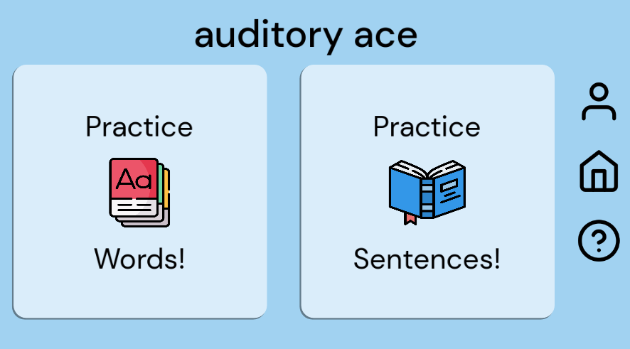

Home Screen as of 3/3/23

## Main Menu Code Documentation

The main menu serves as the primary interface for users to navigate through the application or game. It provides access to essential features and functionalities. Here's an overview of the main menu:

### Title and Logo

The main menu typically displays the title of the application or game along with a logo or visual identifier. This helps users recognize the brand or purpose of the software.

### Navigation Buttons:

* The main menu contains various buttons that allow users to navigate to different sections or screens within the application. These buttons are often labeled with descriptive text or icons to indicate their function.

### Functionality Buttons:

* Profile: Allows users to access their profile information or settings.
* Home: Navigates users back to the main screen or starting point of the application.
* Help: Provides assistance or guidance to users, such as instructions or FAQs.
* Exercise One and Exercise Two: These buttons lead users to specific exercises or tasks within the application.

### Visual Elements:

* The main menu may include visual elements such as background colors, images, or animations to enhance its aesthetic appeal and reinforce the application's theme or branding.

### Interactivity:

* Buttons in the main menu are interactive, responding to user input such as mouse clicks or touch gestures. They trigger actions like scene transitions or opening specific functionalities within the application.

## Intro Screen Code Documentation

The intro screen, or introductory screen, is the initial interface that users encounter when launching the Auditory Ace application. Its primary purpose is to provide a brief introduction or welcome message to users. Here's an overview of the components within the intro screen:

### Title Label (AppTitle):

* Displays the application or game title "uditory ace".
* Positioned at the center of the screen to ensure visibility.
* Utilizes the DMSans font with a font size of 80 for clear readability.
* Aligned horizontally and vertically for aesthetic presentation.

### Image (Img9060):

* Represents an image relevant to the application or game.
* Positioned at a specific location for visual appeal.
* Scaled and rotated for proper fitting within the layout.

### Background (ColorRect):

* Provides a colored background to the intro screen.
* Utilizes a light blue color (RGB: 0.631373, 0.823529, 0.945098) for a soothing and welcoming appearance.
* Covers the entire screen to ensure uniformity.

### Timer:

* A timer set to trigger after 2 seconds (wait_time = 2.0).
* Configured as a one-shot timer (one_shot = true) to trigger only once.
* Automatically starts upon the intro screen's initialization (autostart = true).

### Acknowledgment Label (Label):

* Displays an acknowledgment message "Made by Devious Developers".
* Positioned below the title for credit attribution.
* Utilizes the JosefinSans-Regular font with a font size of 20 for subtlety.

### Script:

* Linked to an external script file (intro_screen.gd) for handling logic and interactions.

### Signal Connection:

* Connects the timeout signal emitted by the Timer node to a method named _on_timer_timeout.
* This signal connection triggers a transition to the main menu after the specified time interval.

The intro screen sets the tone for the user experience and creates a positive first impression, welcoming users to the application environment.



Intro Screen as of 3/10/24